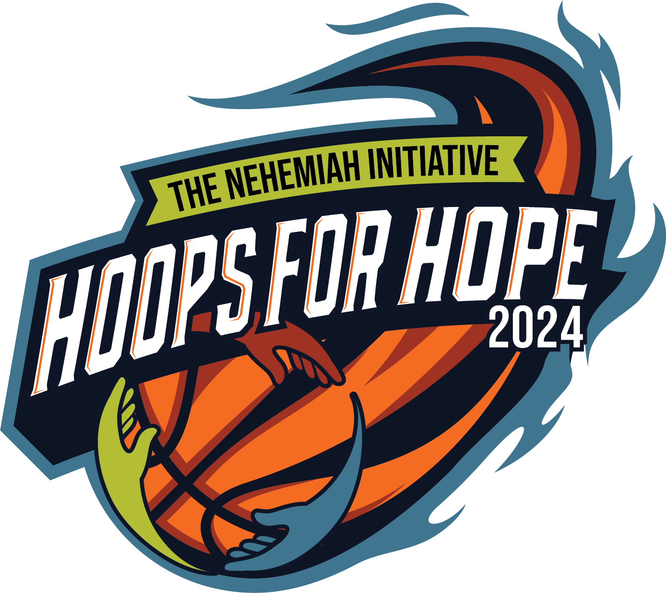Hoops for Hope 3 on 3 Basketball Tournament

Saturday, August 3rd and Sunday, August 4th

Sponsorship Opportunities

Company Name as it should appear on marketing:

___________________________________________________________

Contact Name:____________________________________________________________________

Email Address:____________________________________________________________________

Phone Number:____________________________________________________________________

Billing Address:____________________________________________________________________

________________________________________________________________________________

**Payment and Logo Deadline 6/15/2024**

Payments made by credit card please visit https://www.nehemiahnc.org. Payments by check are to be made out to The Nehemiah Initiative and mailed to the Attention of Gregg Green, The Nehemiah Initiative, P.O. Box 1563 Winterville, NC 28590.

* **Presenting Sponsor $7,500** (exclusive)
* **Championship Court Sponsor $5,000** (exclusive)
* **Courtside Sponsor $3,000** (25 courts)
* **Baseline Sponsor $1,500**

Choose one: ______Free Throw contest, ______Slam Dunk contest, ______Three - Point contest, ______Kids Corner, ______Partners Pavilion, ______Hydration Station, ______First- Aid Tent, ______Food Truck Zone

* **Bracket Sponsor $500**

Choose one: ______Youth (8 to 10 years old boys and girls),______ Middle School (11 to 13 years old boys and girls), ______High School Boys(14 to 18 years old),______High School Girls (14 to 18 years old), ______Adult Females (19 years old and up),______Elite Adult Females (19 years old and up, ______Adult Males (19 years old and up), ______Elite Adult Males (19 years old and up), ______Exceptional League (all ages,co-ed), _______Seniors (65 and up, coed)

The Nehemiah Initiative is a non-profit that seeks to build and maintain healthy families in our community.