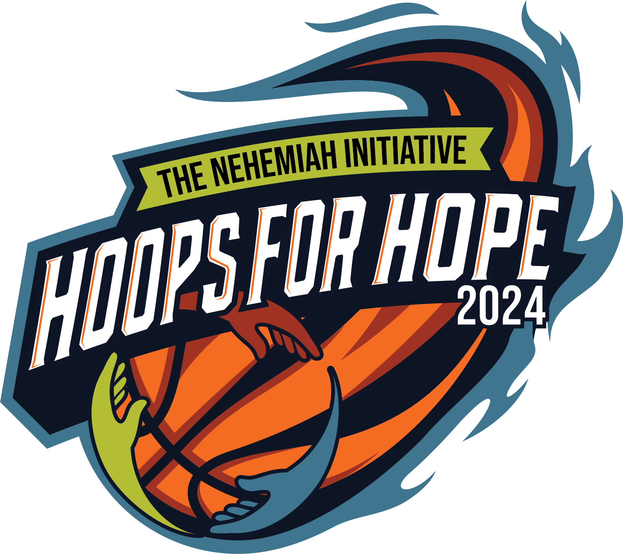Hoops for Hope 3 on 3 Basketball Tournament

Sponsorship Opportunities

**Presenting Sponsor $7,500** (exclusive)

* Prominent placement of logo on all event marketing materials
* Recognition on all media advertising
* Social media promotion
* Verbal recognition at event
* Opportunity to provide promotional materials to participants
* Logo on back of event t-shirt
* One 3 on 3 team

**Championship Court Sponsor $5,000** (exclusive)

* Social media promotion
* Verbal recognition at event
* Championship courtside recognition (logo decal on hoop)
* Award presentation recognition
* Logo on back of event t-shirt
* One 3 on 3 team

**Courtside Sponsor $3,000** (25 courts)

* Social media promotion
* Courtside recognition (logo decal on hoop)
* Verbal recognition at event
* Listed on back of event t-shirt
* One 3 on 3 team

**Baseline Sponsor $1,500**

* Social media promotion
* Verbal recognition at event
* Logo recognition by place of choice

Choose one: ______Free Throw contest, ______Slam Dunk contest, ______Three - Point contest, ______Kids Corner, ______Partners Pavilion, ______Hydration Station, ______First- Aid Tent, ______Food Truck Zone

**Bracket Sponsor $500**

* Logo recognition on a division bracket posted at event

Choose one: ______Youth (8 to 10 years old boys and girls),______ Middle School (11 to 13 years old boys and girls), ______High School Boys(14 to 18 years old),______High School Girls (14 to 18 years old), ______Adult Females (19 years old and up),______Elite Adult Females (19 years old and up, ______Adult Males (19 years old and up), ______Elite Adult Males (19 years old and up), ______Exceptional League (all ages,co-ed), _______Seniors (65 and up, coed)

Tournament to be held on Saturday, August 3rd and Sunday August 4th